**C64 Cart64out Rev. 0**

**Module description**

# Introduction

This board is a breakout board for the C64 (C128) expansion port. It can also serve several other purposes:

* Expansion port breakout board for connecting a scope or logic analyzer
* Breakout board for connecting a bread board
* Cartridge read out and analysis tool
* A simple reset-switch

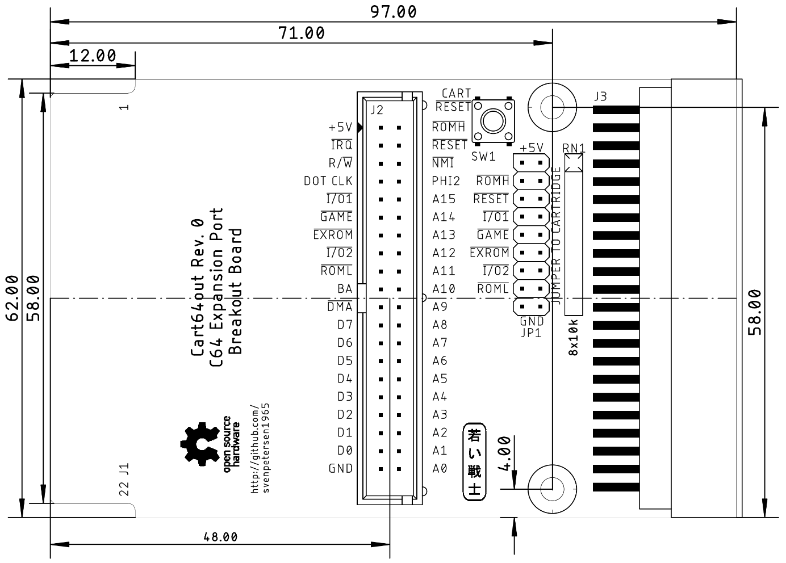

Figure 1: Cart64out dimensions

All signals of the expansion port are connected to the pin header J2. GND and +5V are only connected once to be able to use a standard 2x20p. pin header. All signals are connected to the edge connector J3. Some of those signals have to pass the jumper JP1, though, so they can be interrupted by pulling out the associated jumper. The resistor network RN1 serves as pull-up resistor on the cartridge side, so an open jumper means, that this signal is HIGH on the cartridge side.

The reset-switch SW1 is connected to the cartridge side of the reset signal. As long as the jumper labeled is closed, it is effective for the cartridge and the C64. While this jumper is open, it only resets the cartridge.

JP1 can also be controlled by a micro controller for a comfortable read out of the cartridge. The supply voltage +5V and GND are connected on adjacent pins for this purpose. Those jumper pins are not required to be closed with a jumper.

|  |  |  |  |
| --- | --- | --- | --- |
| Signal | Pin | Pin | Signal |
| +5V | 1 | 2 | +5V |
|  | 3 | 4 |  |
|  | 5 | 6 |  |
|  | 7 | 8 |  |
|  | 9 | 10 |  |
|  | 11 | 12 |  |
|  | 13 | 14 |  |
|  | 15 | 16 |  |
| GND | 17 | 18 | GND |

Table 1: Pinout of Jumper JP1

Cart64out aims at the experienced hardware amateur, who wants to get deeper into the functionality of C64 cartridges. It can also be helpful while repairing a C64, because some of the signals, like , PHI2 or DOT CLOCK or stuck address or data lines can be monitored by scope without opening the C64.

The drills serve to install bolts adjusted to height to support the Cart64out. A length of 17mm – 18mm works best for both sorts of cases (C64 and C64C).

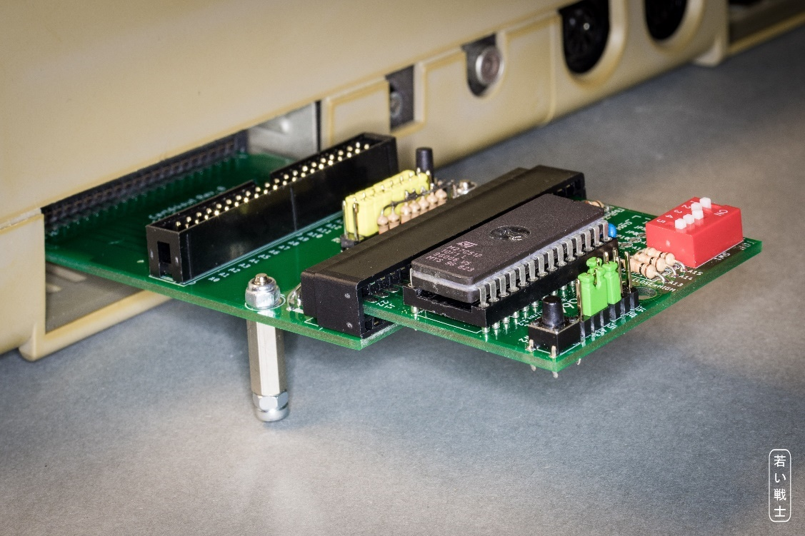

Figure 2: Supporting bolts

# Pinouts

## J1 – Expansion Port

| Pin (TOP) | Signal | Pin | Signal (BOT) |
| --- | --- | --- | --- |
| 1 | GND | A | GND |
| 2 | +5V | B |  |
| 3 | +5V | C |  |
| 4 |  | D |  |
| 5 | R / | E | PHI2 |
| 6 | DOT CLOCK | F | A15 |
| 7 |  | H | A14 |
| 8 |  | J | A13 |
| 9 |  | K | A12 |
| 10 |  | L | A11 |
| 11 |  | M | A10 |
| 12 | BA | N | A9 |
| 13 |  | P | A8 |
| 14 | D7 | R | A7 |
| 15 | D6 | S | A6 |
| 16 | D5 | T | A5 |
| 17 | D4 | U | A4 |
| 18 | D3 | V | A3 |
| 19 | D2 | W | A2 |
| 20 | D1 | X | A1 |
| 21 | D0 | Y | A0 |
| 22 | GND | Z | GND |

## J2 – Break out connector

2x20 box header, 2.54mm pitch

| Pin | Signal | Pin | Signal |
| --- | --- | --- | --- |
| 1 | +5V | 2 |  |
| 3 |  | 4 |  |
| 5 | R / | 6 |  |
| 7 | DOT CLOCK | 8 | PHI2 |
| 9 |  | 10 | A15 |
| 11 |  | 12 | A14 |
| 13 |  | 14 | A13 |
| 15 |  | 16 | A12 |
| 17 |  | 18 | A11 |
| 19 | BA | 20 | A10 |
| 21 |  | 22 | A9 |
| 23 | D7 | 24 | A8 |
| 25 | D6 | 26 | A7 |
| 27 | D5 | 28 | A6 |
| 29 | D4 | 30 | A5 |
| 31 | D3 | 32 | A4 |
| 33 | D2 | 34 | A3 |
| 35 | D1 | 36 | A2 |
| 37 | D0 | 38 | A1 |
| 39 | GND | 40 | A0 |

## J3 – Cartridge Connector

Card Edge Connector 22x2P 2.54mm (0.1“) Right Angle

| Pin (TOP) | Signal | Pin | Signal (BOT) |
| --- | --- | --- | --- |
| 1 | GND | A | GND |
| 2 | +5V | B |  |
| 3 | +5V | C |  |
| 4 |  | D |  |
| 5 | R / | E | PHI2 |
| 6 | DOT CLOCK | F | A15 |
| 7 |  | H | A14 |
| 8 |  | J | A13 |
| 9 |  | K | A12 |
| 10 |  | L | A11 |
| 11 |  | M | A10 |
| 12 | BA | N | A9 |
| 13 |  | P | A8 |
| 14 | D7 | R | A7 |
| 15 | D6 | S | A6 |
| 16 | D5 | T | A5 |
| 17 | D4 | U | A4 |
| 18 | D3 | V | A3 |
| 19 | D2 | W | A2 |
| 20 | D1 | X | A1 |
| 21 | D0 | Y | A0 |
| 22 | GND | Z | GND |

The signals marked with * can be interrupted by a jumper (see Table 1).